Type of the paper (Research paper, Review, Editorial, etc.)
MANUSCRIPT TITLE (avoid using any acronyms in the title; less than 20 words)

Ivan I. Ivanov¹, Anton A. Petrov¹*, David H. Smith²
¹University/Organization name, address, ZIP-code, City, Country
²University/Organization name, address, ZIP-code, City, Country

* Corresponding author: example@example.com

ABSTRACT. Abstract must be written in Times New Roman, pt. 12 and be not less than 200 and no more than 250 words.

KEY WORDS: (Immediately after the abstract, provide a maximum of 6 keywords, avoiding general and plural terms and multiple concepts (avoid, for example, 'and', 'of'). Be sparing with abbreviations: only abbreviations firmly established in the field may be eligible. These keywords will be used for indexing purposes.).

ACKNOWLEDGEMENTS
List here those individuals who provided help during the research and funds which provided financial support of your research.

CONFLICTS OF INTEREST
List here the persons and/or organizations, which may have potential conflict of interest with authors and presented data. Otherwise just leave the statement “The authors reported no potential conflicts of interest.”

INTRODUCTION
(State the objectives of the work and provide an adequate background, avoiding a detailed literature survey or a summary of the results.).

MATERIALS AND METHODS
Provide sufficient details to allow the work to be reproduced by an independent researcher. Methods that are already published should be summarized, and indicated by a reference. If quoting directly from a previously published method, use quotation marks and also cite the source. Any modifications to existing methods should also be described. This section may include The study area subsection.
Math equations should be submitted as editable text and not as images (use appropriate tool in text editor). Present simple formulae in line with normal text where possible and use the solidus (/) instead of a horizontal line for small fractional terms, e.g., X/Y. In principle, variables are to be presented in italics. Number consecutively any equations that have to be displayed separately from the text (if referred to explicitly in the text):
$∆T=\sum_{l}{f_{l}∆T_{l}}=T_{u}-\sum_{l}{{f_{l}T}_{l}}=T_{u}-T_{r}$ (1),

Figures and figure captions. Number the illustrations according to their sequence in the text. Regardless of the application used, when your figure is finalized, please 'save as' or convert the images to one of the following formats: TIFF, JPG. Supply files that are optimized for screen use. The resolution should be at least 300 dpi. Besides inserting figures into your manuscript, you must also upload appropriate files and email them to Editorial board’s email. Ensure that each illustration has a caption. A caption should comprise a brief title (not on the figure itself) and a description of the illustration beginning from “Fig. 1…”. Keep text in the illustrations themselves to a minimum but explain all symbols and abbreviations used.
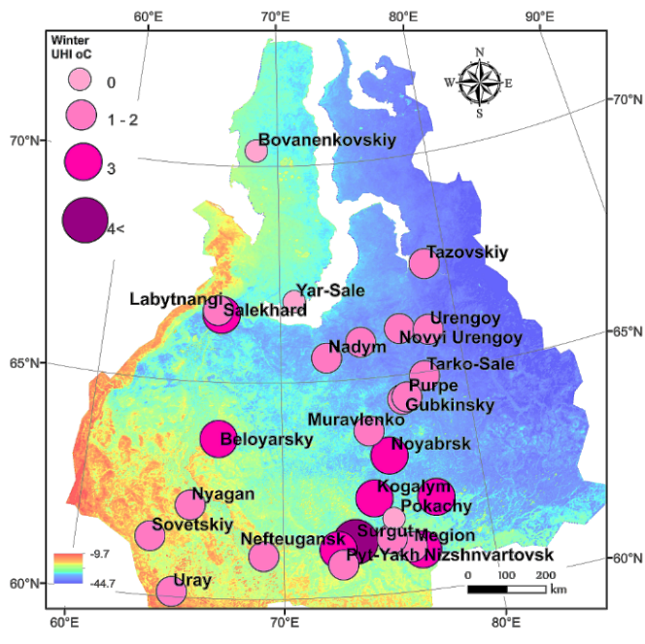  (a) | 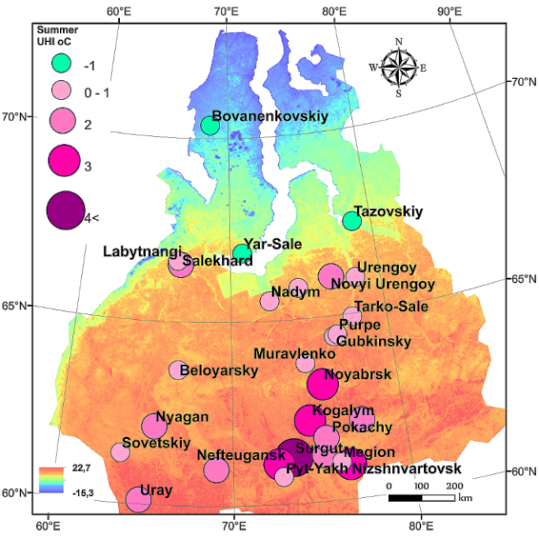  (b)
Fig. 1. Description must be clear and short. All figures must be duplicated with high-resolution (300 dpi or more) raster-files sent to journal Editorial Office (ges-journal@geogr.msu.ru)

Tables. Please submit tables as editable text and not as images. Tables can be placed either next to the relevant text in the article, or on separate page(s) at the end. Number tables consecutively in accordance with their appearance in the text, place table caption above the table body and place any table notes below the body. Be sparing in the use of tables and ensure that the data presented in them do not duplicate results described elsewhere in the article. Please avoid using vertical rules and shading in table cells.
Example:

Table 1. Case studies and used methods.
Column 1 | Parameter 1 | Parameter 2 | Parameter 3 | Parameter 4 | Parameter 5

The optimum size of a manuscript is about 3,000–5,000 words. Under the decision (or request) of the Editorial Board methodological and problem articles or reviews up to 8,000–10,000 words long can be accepted. The manuscript must be provided both in WORD and PDF files.

RESULTS
Sub-section title
Results should be clear and concise.

DISCUSSION
This should explore the significance of the results of the work, not repeat them. A combined Results and Discussion section is often appropriate. Avoid extensive citations and discussion of published literature.

CONCLUSIONS
The main conclusions of the study may be presented in a short Conclusions section, which may stand alone or form a subsection of a Discussion or Results and Discussion section.

REFERENCES
Make a list of references according to guidance provided on website. Below you can find several examples of the references.

Dismuke C. and Egede L. (2015). The Impact of Cognitive, Social and Physical Limitations on Income in Community Dwelling Adults with Chronic Medical and Mental Disorders. Global Journal of Health Science, 7(5), 183-195, DOI: 10.15356/2076-6734-2013-1-34-42.
Konishchev V. (2013) The nature of the cyclic structure of the ice complex of Eastern Siberia, Earth Cryosphere, vol. XVII, №1, 3-16 (in Russian with English summary). DOI: 10.15356/2076-6734-2013-1-34-42.
Mms.com, (2015). M&M'S Official Website. [online] Available at: http://www.mms.com/ [Accessed 20 Apr. 2015].
Raina S. (2015). Establishing Correlation Between Genetics and Nonresponse. Journal of Postgraduate Medicine, [online] Volume 61(2), p. 148. Available at: http://www.proquest.com/products-services/ProQuest-Research-Library.html [Accessed 8 Apr. 2015], DOI: 10.15356/2076-6734-2013-1-34-42.
Ross N. (2015). On Truth Content and False Consciousness in Adorno’s Aesthetic Theory. Philosophy Today, 59(2), 269-290. DOI: 10.15356/2076-6734-2013-1-34-42.

APPENDICES
If there is more than one appendix, they should be identified as A, B, etc. Formulae and equations in appendices should be given separate numbering: Eq. (A.1), Eq. (A.2), etc.; in a subsequent appendix, Eq. (B.1) and so on. Similarly for tables and figures: Table A.1; Fig. A.1, etc.).

